**Problem Statement**

City Hotel and Resort Hotel wanted to understand the factors influencing Hotel booking cancellations by their respective customers, so that they can improve their customer services.

**Dataset**

This dataset contains 119390 observations for a City Hotel and a Resort Hotel. Each observation represents a hotel booking between the 1st of July 2015 and 31st of August 2017, including booking that effectively arrived and booking that were cancelled.

**Data Cleaning**

1. **Removing redundant columns:**

In the original data file, we have 32 columns. For this Project we are doing a simple analysis. So, we have deleted many of the one and kept only the below 13 columns.

1. hotel
2. is_canceled
3. arrival_date_year
4. arrival_date_month
5. adults
6. children
7. babies
8. country
9. reserved_room_type
10. assigned_room_type
11. adr
12. reservation_status
13. reservation_status_date
14. **Handling NULL Values**: *'agent’* and *‘company’* column have many null values, but we’ve already remove them.

**Data Processing**

We ‘ve added extra 3 columns:

1. **room_status** =IF([@[reserved_room_type]] = [@[assigned_room_type]],"Desired","Un-Desired")
2. **guest_type =**IF(AND([@adults]=2,[@children]=0,[@babies]=0),"Couples",IF(AND([@adults]=1,[@children]=0,[@babies]=0),"Single","Family"))
3. **months** =LEFT([arrival_date_month],3)

**Dashboard Creation**

We create the necessary pivot tables then charts on them. Finally, below is the dashboard we created.

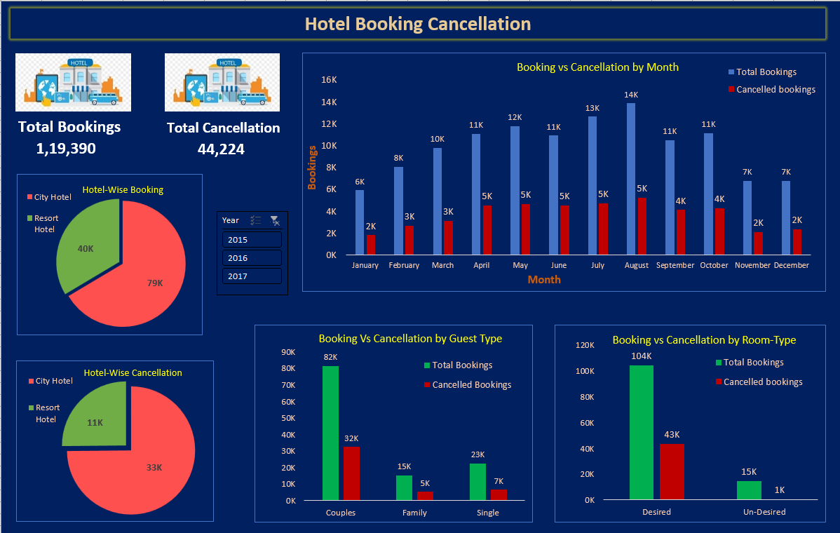

**Conclusions:**

1. Total Bookings is 119390 (60% is for City Hotel – 79330)
2. Total Cancellation is 44,224 (75% of total cancellation belons to City Hotel – 33101)
3. Couples cancel most of the bookings. But they also are among the one that contributes to the hotel booking.

a). Couples cancel 40% of their bookings. (32424 out of 81560)

b). Family cancels 34% of their bookings. (5245 out of 15253)

c). Single cancels 29% of their bookings. (6555 out of 22577)

1. 42% of booking get cancelled, even on getting desired rooms, while only 5% booking get cancelled on not getting desired rooms. This means, Getting Desired room has no correlation with booking cancellations.
2. Booking is highest in the month of August and so is the Cancellations. But percentage-wise April, May and June sees around 41% cancellation.